Министерство образования Республики Беларусь
Учреждение образования
«Брестский государственный технический университет»
Кафедра ИИТ

Лабораторная работа №2
По дисциплине: «Естественно-языковой интерфейс ИС»

Тема: «Разработка системы автоматического реферирования документов»

Выполнил:
Студент 4 курса
Группы ИИ-23
Макаервич Н.Р.

Проверил:
Булей Е.В.

Брест 2025
Ход работы
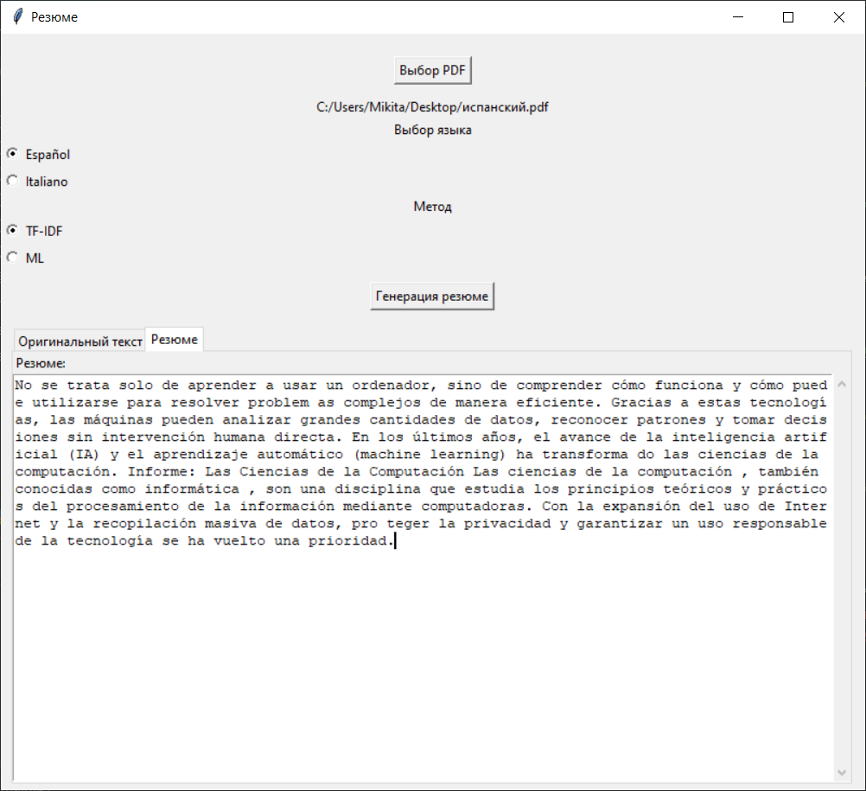
Код программы:
import re
import nltk
import tkinter as tk
from tkinter import filedialog, Text, ttk
from sklearn.feature_extraction.text import TfidfVectorizer
from transformers import T5ForConditionalGeneration, T5Tokenizer
import threading
import PyPDF2
nltk.download('punkt', quiet=True)
nltk.download('stopwords', quiet=True)
from nltk.corpus import stopwords
from nltk.tokenize import sent_tokenize, word_tokenize
ml_model = None
ml_tokenizer = None
ml_loaded = False
def load_ml_model():
global ml_model, ml_tokenizer, ml_loaded
try:
model_name = "t5-small"
ml_model = T5ForConditionalGeneration.from_pretrained(model_name)
ml_tokenizer = T5Tokenizer.from_pretrained(model_name)
ml_loaded = True
except Exception as e:
print(f"Error loading ML model: {e}")
ml_loaded = False
load_ml_model()
def extract_text_from_pdf(pdf_file):
text = ""
try:
with open(pdf_file, 'rb') as file:
reader = PyPDF2.PdfReader(file)
for page in reader.pages:
page_text = page.extract_text()
if page_text:
text += page_text + "\n"
except Exception as e:
print(f"Error reading PDF: {e}")
return text
def clean_text(text):
text = re.sub(r'\s+', ' ', text)
text = re.sub(r'\d+', '', text)
return text
def extract_sentences_tfidf(text, language='spanish'):
sentences = sent_tokenize(text)
if not sentences:
return [], []
try:
stop_words = set(stopwords.words(language))
except:
stop_words = set(stopwords.words('english'))
cleaned_sentences = [' '.join([word for word in word_tokenize(sentence.lower())
if word.isalpha() and word not in stop_words])
for sentence in sentences]
if not any(cleaned_sentences):
return sentences, [1.0] * len(sentences)
vectorizer = TfidfVectorizer()
tfidf_matrix = vectorizer.fit_transform(cleaned_sentences)
return sentences, tfidf_matrix.sum(axis=1).A1
def generate_summary(sentences, sentence_weights, summary_length=5):
if not sentences:
return "No text available for summarization."
ranked_sentences = sorted(((weight, sentence) for sentence, weight in zip(sentences, sentence_weights)),
reverse=True)
summary_length = min(summary_length, len(ranked_sentences))
summary = ' '.join([sentence for weight, sentence in ranked_sentences[:summary_length]])
return summary
def generate_ml_summary(text):
if not ml_loaded:
return "ML model not available. Please check console for errors."
try:
if len(text) > 1000:
text = text[:1000] + "..."
input_text = "summarize: " + text
inputs = ml_tokenizer(input_text, return_tensors="pt", max_length=512, truncation=True)
summary_ids = ml_model.generate(
inputs["input_ids"],
max_length=100,
min_length=30,
length_penalty=2.0,
early_stopping=True
)
summary = ml_tokenizer.decode(summary_ids[0], skip_special_tokens=True)
return summary
except Exception as e:
return f"Error generating ML summary: {str(e)}"
def summarize_pdf(pdf_file, method, language='spanish'):
text = extract_text_from_pdf(pdf_file)
if not text.strip():
return "No text extracted from PDF", "Cannot summarize empty text"
cleaned_text = clean_text(text)
if method == "TF-IDF":
sentences, sentence_weights = extract_sentences_tfidf(cleaned_text, language)
summary = generate_summary(sentences, sentence_weights)
elif method == "ML":
summary = generate_ml_summary(cleaned_text)
else:
summary = "Unknown method"
return text, summary
def open_file():
filepath = filedialog.askopenfilename(filetypes=[("PDF files", "*.pdf")])
if filepath:
selected_file.set(filepath)
original_text_box.delete(1.0, tk.END)
original_text_box.insert(tk.END, "Текст...")
threading.Thread(target=extract_and_display_text, args=(filepath,)).start()
def extract_and_display_text(filepath):
text = extract_text_from_pdf(filepath)
original_text_box.delete(1.0, tk.END)
original_text_box.insert(tk.END, text)
def run_summarize():
if not selected_file.get():
summary_text_box.delete(1.0, tk.END)
summary_text_box.insert(tk.END, "Выберите PDF")
return
summary_text_box.delete(1.0, tk.END)
summary_text_box.insert(tk.END, "Генерация резюме...")
root.update()
threading.Thread(target=summarize).start()
def summarize():
try:
method_choice = method.get()
language_choice = language_var.get()
original_text, summary = summarize_pdf(selected_file.get(), method_choice, language_choice)
root.after(0, update_results, original_text, summary)
except Exception as e:
root.after(0, show_error, str(e))
def update_results(original_text, summary):
original_text_box.delete(1.0, tk.END)
original_text_box.insert(tk.END, original_text)
summary_text_box.delete(1.0, tk.END)
summary_text_box.insert(tk.END, summary)
def show_error(error_msg):
summary_text_box.delete(1.0, tk.END)
summary_text_box.insert(tk.END, f"Error: {error_msg}")
root = tk.Tk()
root.title("Резюме")
root.geometry("800x700")
selected_file = tk.StringVar()
method = tk.StringVar(value="TF-IDF")
language_var = tk.StringVar(value="spanish")
status_frame = tk.Frame(root)
status_frame.pack(pady=5)
file_button = tk.Button(root, text="Выбор PDF", command=open_file)
file_button.pack(pady=10)
file_label = tk.Label(root, textvariable=selected_file)
file_label.pack()
language_label = tk.Label(root, text="Выбор языка")
language_label.pack()
spanish_radio = tk.Radiobutton(root, text="Español", variable=language_var, value="spanish")
spanish_radio.pack(anchor="w")
italian_radio = tk.Radiobutton(root, text="Italiano", variable=language_var, value="italian")
italian_radio.pack(anchor="w")
method_label = tk.Label(root, text="Метод")
method_label.pack()
tfidf_radio = tk.Radiobutton(root, text="TF-IDF", variable=method, value="TF-IDF")
tfidf_radio.pack(anchor="w")
ml_radio = tk.Radiobutton(root, text="ML", variable=method, value="ML")
ml_radio.pack(anchor="w")
if not ml_loaded:
ml_warning = tk.Label(root, text="(ML не зашркжена)", fg="red")
ml_warning.pack(anchor="w")
summarize_button = tk.Button(root, text="Генерация резюме", command=run_summarize)
summarize_button.pack(pady=10)
notebook = ttk.Notebook(root)
notebook.pack(fill=tk.BOTH, expand=True, padx=10, pady=5)
original_frame = ttk.Frame(notebook)
notebook.add(original_frame, text="Оригинальный текст")
original_text_label = tk.Label(original_frame, text="Оригинальный текст")
original_text_label.pack(anchor="w")
original_text_box = Text(original_frame, height=12, width=80)
original_scrollbar = tk.Scrollbar(original_frame, command=original_text_box.yview)
original_text_box.configure(yscrollcommand=original_scrollbar.set)
original_text_box.pack(side=tk.LEFT, fill=tk.BOTH, expand=True)
original_scrollbar.pack(side=tk.RIGHT, fill=tk.Y)
summary_frame = ttk.Frame(notebook)
notebook.add(summary_frame, text="Резюме")
summary_text_label = tk.Label(summary_frame, text="Резюме:")
summary_text_label.pack(anchor="w")
summary_text_box = Text(summary_frame, height=12, width=80)
summary_scrollbar = tk.Scrollbar(summary_frame, command=summary_text_box.yview)
summary_text_box.configure(yscrollcommand=summary_scrollbar.set)
summary_text_box.pack(side=tk.LEFT, fill=tk.BOTH, expand=True)
summary_scrollbar.pack(side=tk.RIGHT, fill=tk.Y)
root.mainloop()

Вывод: в ходе выполнения лабораторной работы освоил основные принципы автоматического реферирования документов.

